|  |  |
| --- | --- |
| **CSE 420**  **Section 01**  **Surprise Quiz 01**  **16th May, 2016**  **Total Time: 10 minutes** | **SET A** |

**Student Name:**

**Student ID:**

1. Define Buffer Pair. [2]

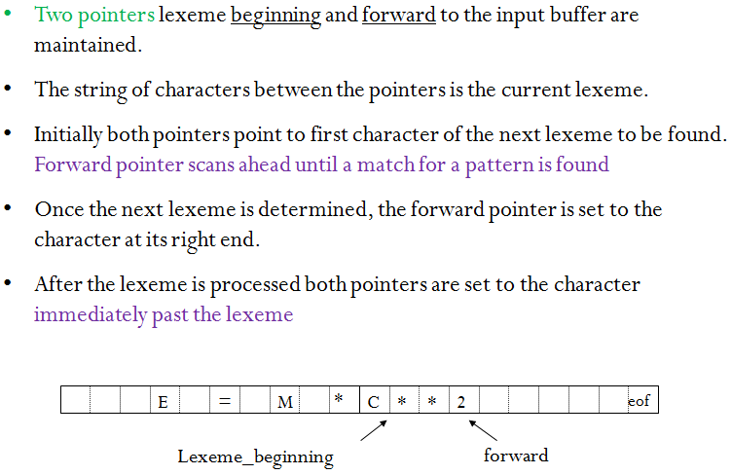

1. Convert the following NFA to DFA using subset construction method. [8]

